# Android App Development

## CodeIt

## Register

Online Emulator Link: <https://appetize.io/app/4bnfcn50me7fg286frrbk2apar>

**Note** : Please use Android Version 10 or above for appetize.io emulator

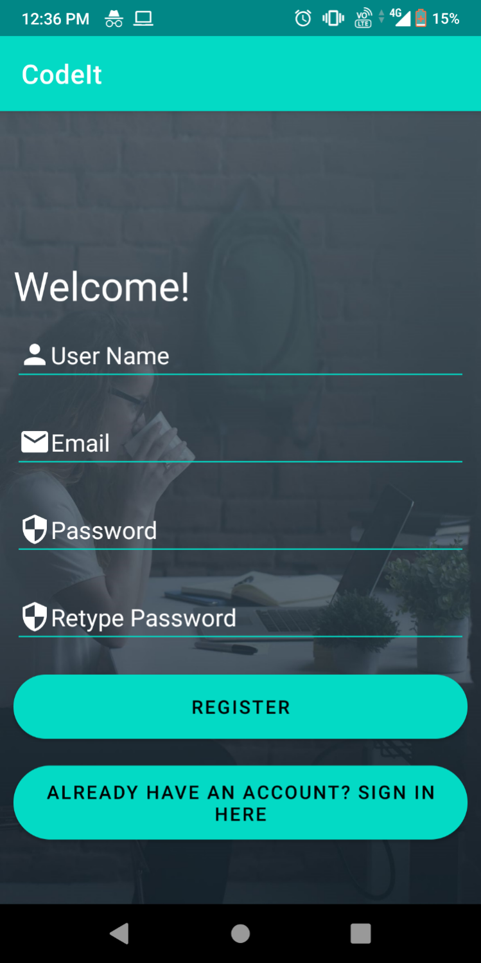

## Login

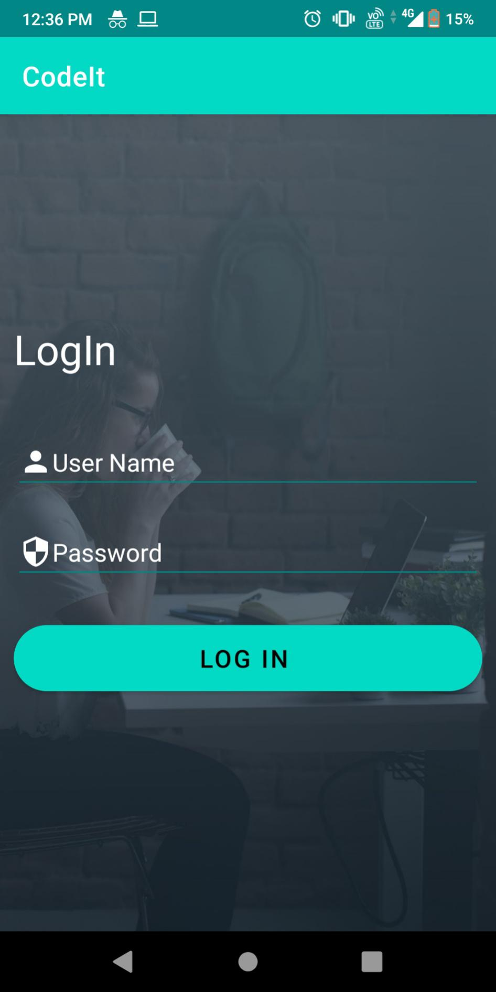

## Recycler View

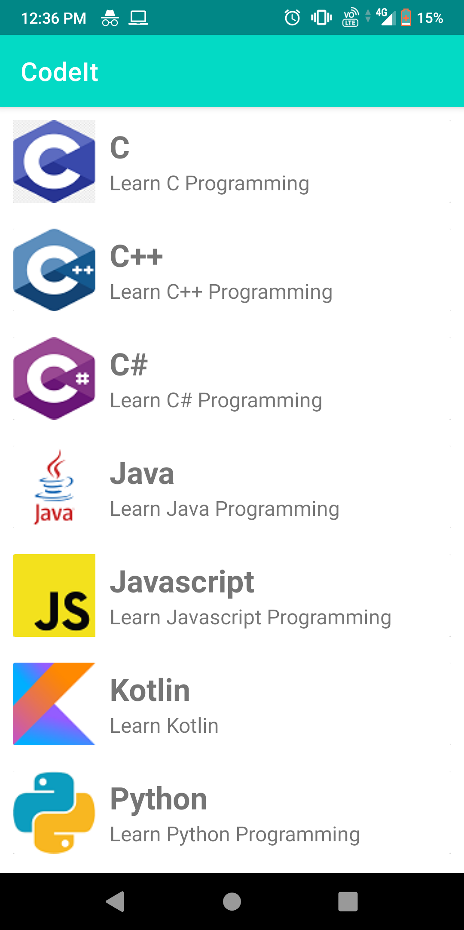

## Detail View

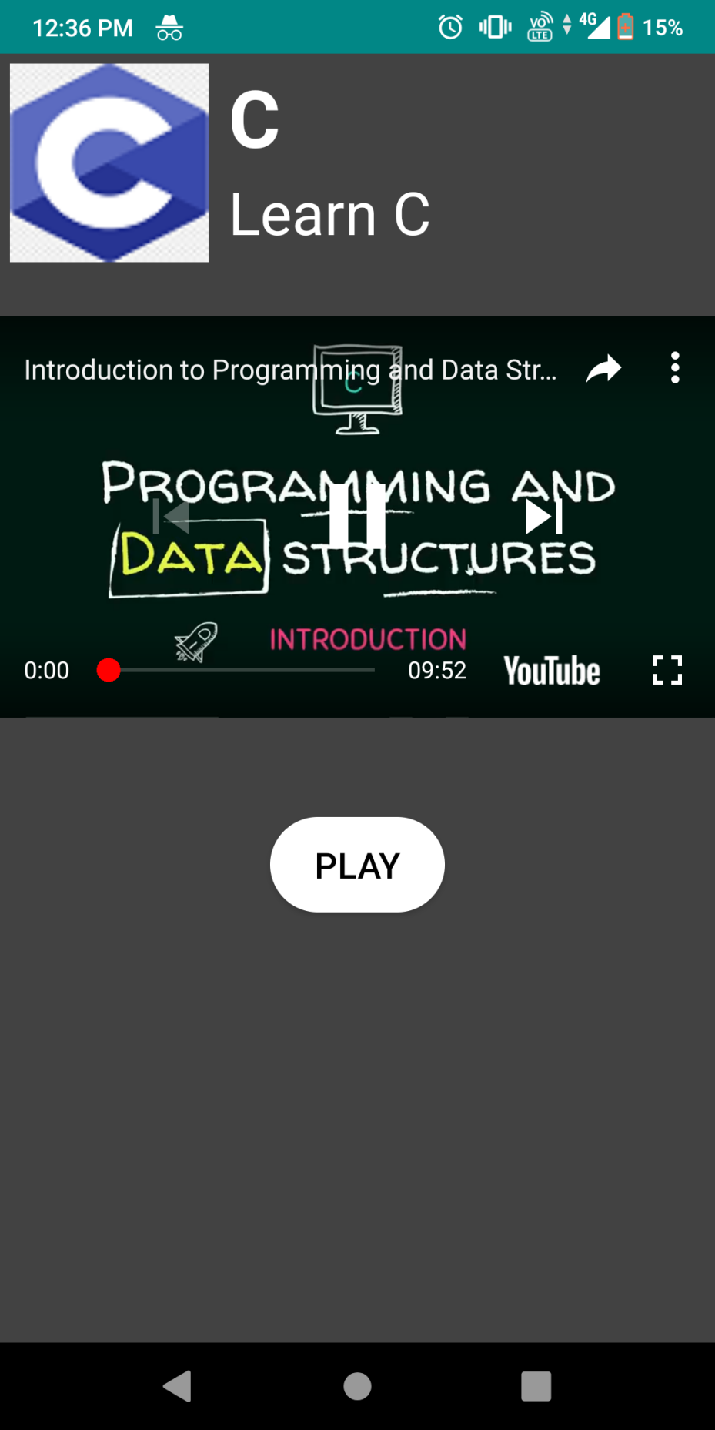

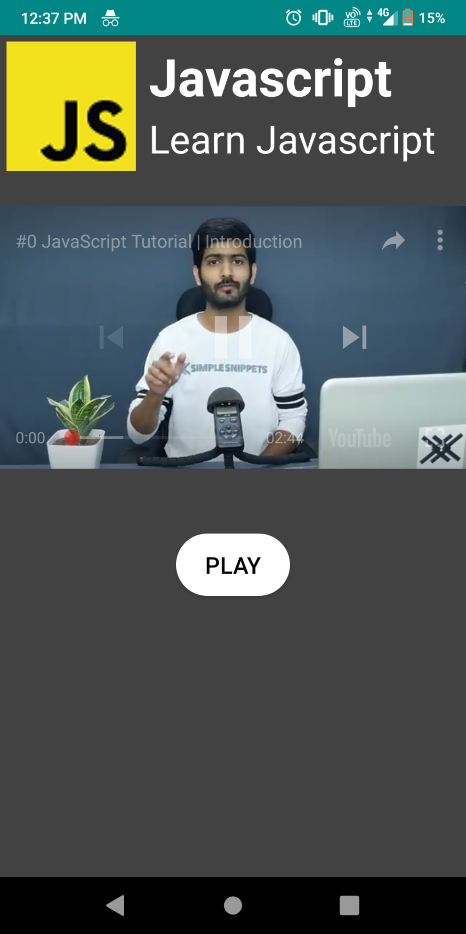

## Hindi Translation

## Register

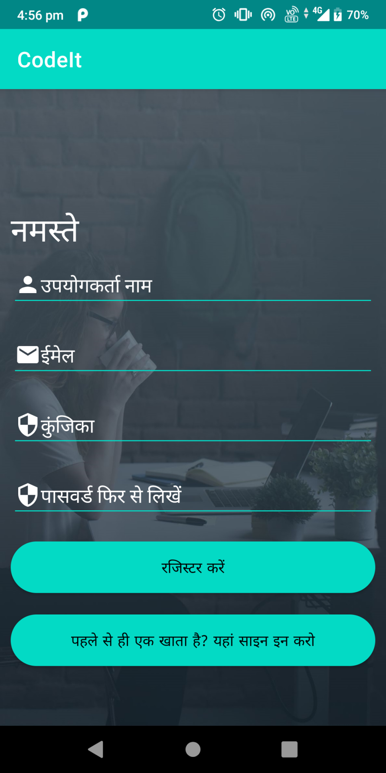

## Login

